Gravestone Worksheet #1 Name:_____________________

Stone #:________

- Use arrows to indicate on your stone where the Lunette, Border, Finial, and Inscription are located. Indicate if the stone does not have one of these elements.

- What shape is your stone (vertical, horizontal, obilesque, individualistic)?

- Transcribe your stone line by line. There are seven basic elements commonly found on gravestone inscriptions: (1) Header, (2) Epithet [terms of praise or identifying labels], (3) Name, (4) Formulas of Death, (5) Date, (6) Eulogies [usually hopes for the person in the afterlife], and (7) Age. Indicate what the parts of the inscription are used in each section.

Inscription | Element

- What symbols are found on each section of the stone?

Lunette:

Finial:

Border:

- What is the significance of each of these symbols? What is the underlying message of the stone?

Stone 1: Groton Cemetery, MA 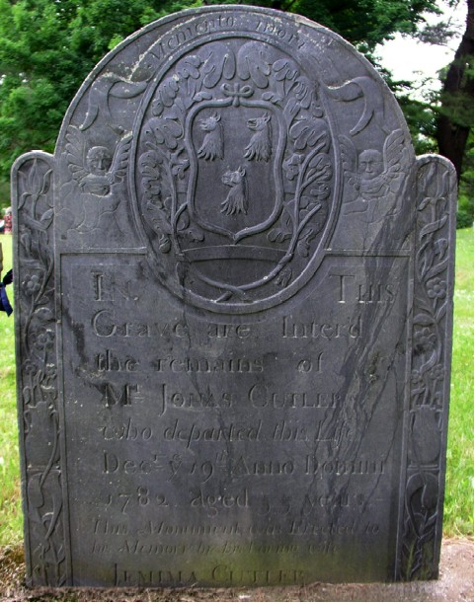

Stone #2: Coddington (Quaker) Cemetery, Newport RI
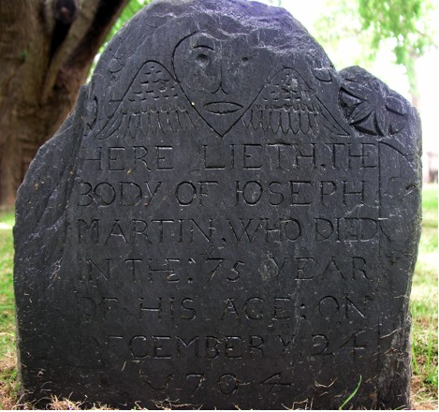

Stone #3: Touro (Jewish) Cemetery, Newport RI
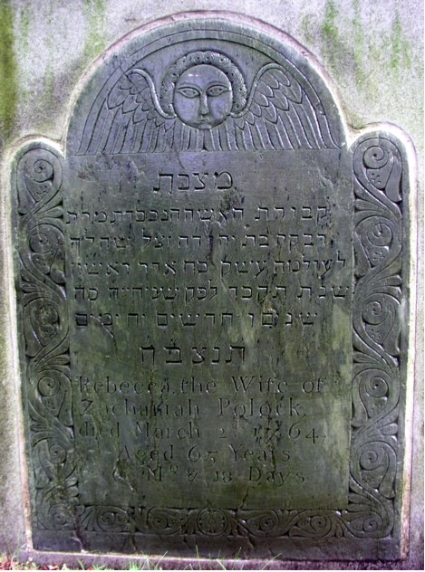

Stone #4: God’s Little Acre (African American) Section
of Common Burying Ground, Newport RI
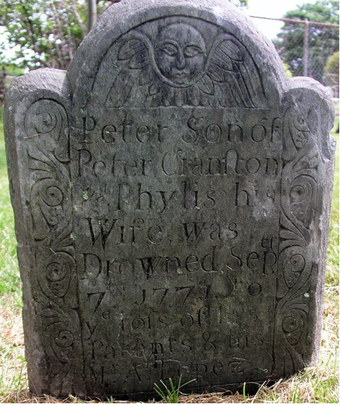

Stone #5: First Church of Cambridge (Cambridge, MA)

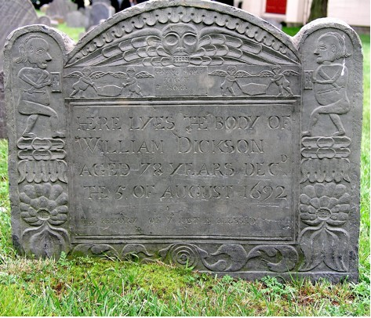

Stone #6: Mashpee Town Cemetery [Old Indian Cemetery], Mashpee, MA
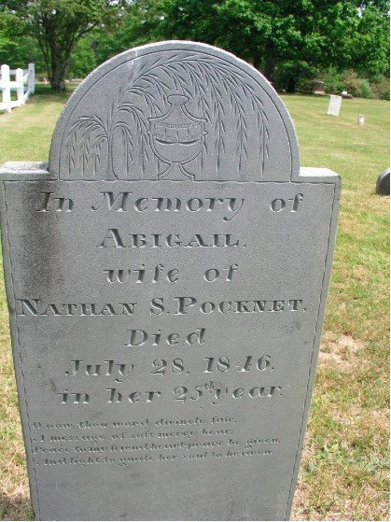
Small Part of Inscription reads:
“O now, thou word divinely fair.
A message of soft mercy bear;
Peace to my friend, heart-peace be given,
And light t guide her soul to heaven.”
Stone #7: West Tisbury Village Cemetery, Martha’s Vineyard, MA



