Humanities 110
Final Exam
Fall 2025

This exam is scheduled for three hours. You may divide your time for the exam as you wish, but we recommend that you limit your time on Part One to one hour and then take roughly one hour each for each essay in Part Two and Part Three (three hours total). Make sure to use some of this time for editing.

This is an open-book, open-note exam. You may consult the assigned course materials, lectures, your notes, and handouts. You may not consult other online materials (including generative AI or large language models such as ChatGPT) or other people for the duration of the exam.

For this exam, as for all other exams at Reed, the Honor Principle applies. Failure to adhere to the requirements set out above will constitute academic misconduct.

Note: students MAY email their responses to the conference leader unless their
conference leader has told them NOT to do so. Students who have accommodations
from DAR are encouraged to use them for the exam. If your accommodation includes
extra time, you may find it helpful to remind your conference leader of this if you have
not done so already.

Part One. Short Answer

(approximately one hour; make sure to use some of this time for editing)

Do a close reading of one passage or artifact from each of the three categories. Be
sure to identify the key themes in the passage and explain why they are important
to the work itself and/or to the larger themes in the course this semester.

1.1. Literary Passages, pick A or B:

- Tale of Sinuhe, p. 42:
"The years were made to pass, from my limbs;
I became clean shaven, and my hair was combed,
A load was given back to the Sand-farers.
I was clad in fine linen;
I was anointed with fine oil.

I slept in a bed.
I returned the sand to those who are upon it,
And the tree oil to those smeared with it."

- Iliad 6, pp. 151-152 (Wilson 6.647–655), Hector speaking:
"Zeus and you other gods, please let my son
be just like me — admired among the Trojans,
strong and successful on the battlefield,
and powerful enough to rule in Troy.
I hope they say when he comes back from war,
'This man is so much better than his father.'
I hope he kills an enemy of ours
and brings his bloodstained arms and armor back,
and makes his mother happy."

1.2 Works of Art, pick A or B:

- Peplos Kore, c. 530 BCE
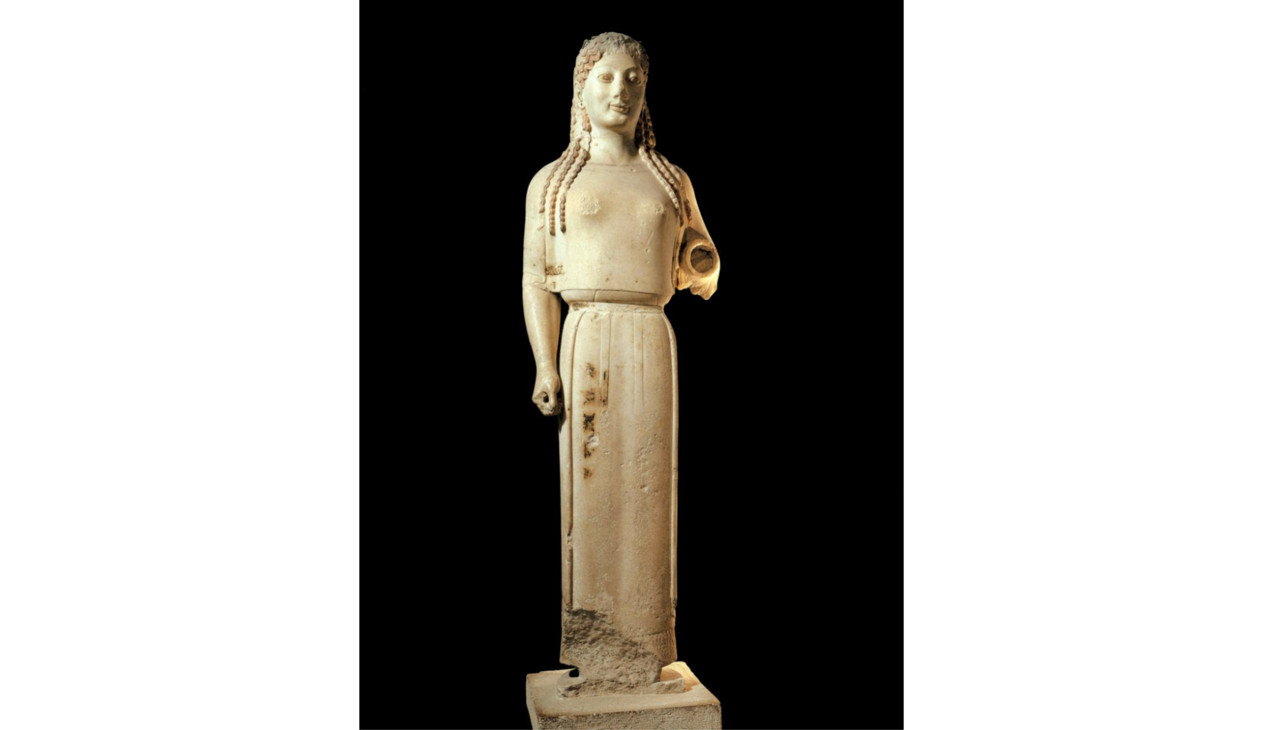

- Pelike, c. 440 BCE
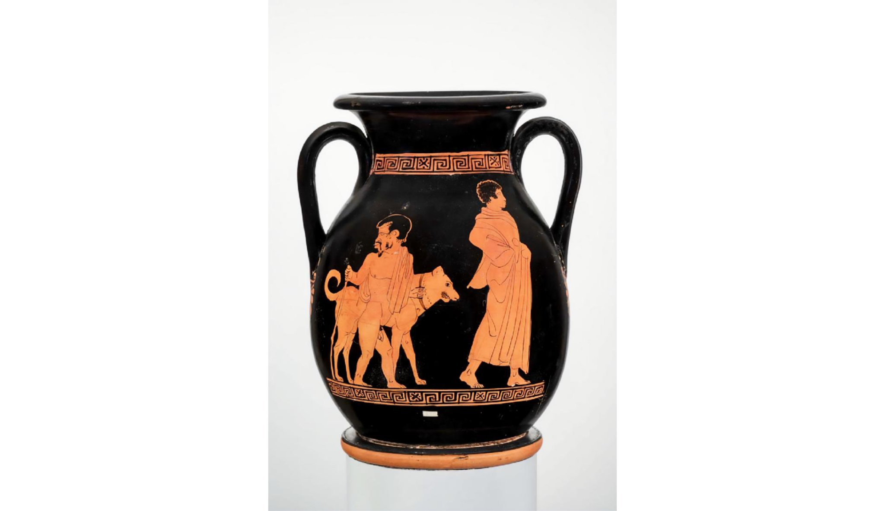

1.3 Passage from Historical or Philosophical Works, pick A or B:

- Genesis, 3.1-5

“Now the serpent was the shrewdest of all the wild beasts that the Lord God had made. He said to the woman, "Did God really say: You shall not eat of any tree of the garden?" The woman replied to the serpent, "We may eat of the fruit of the other trees of the garden. It is only about fruit of the tree in the middle of the garden that God said: 'You shall not eat of it or touch it, lest you die." And the serpent said to the woman, "You are not going to die, but God knows that as soon as you eat of it your eyes will be opened and you will be like divine
beings who know good and bad.”

- Herodotus, The Histories, 1.91 (p. 43)

“As to the oracle, Croesus had no right to find fault with it: the god had declared that if he attacked the Persians he would bring down a mighty empire. After an answer like that, the wise thing would have been to send again to inquire which empire was meant, Cyrus’ or his own. But as he misinterpreted what was said and made no second inquiry, he must admit the fault to have been his own.”
Part Two. Thematic Essay:
(approximately 1 hour; make sure to use some of this time for editing)

Choose one of the following two prompts. Each essay requires analysis of three different works from the syllabus. Be sure that your essay makes an argument and draws on specific examples to support it.

- The works we have analyzed this semester provide different explanations for the causes of violence and its effects on human societies. Construct an argument about the cultural significance of violence, using one work from each of the following three groups:
- “The Tale of Sinuhe”, Exodus, Iliad
- Oresteia, Lysistrata, Esther
- Narmer Palette, Parthenon, Bisitun Monument

- Compare and contrast the attitudes towards nature expressed in three of the following texts or artifacts. How does each work position humanity in relation to nature? Are there notable similarities or differences in the works’ thematic engagements with nature? Choose one work from each group.
- Epic of Gilgamesh, Genesis, Herodotus’s The Histories
- Heraclitus (presocratic philosopher), Love Lyrics of Ancient Egypt (choose one), Sappho’s lyrics (choose one)
- Narmer Palette, Apadana Reliefs, Parthenon

Part Three. Essay.
(approximately 1 hour; make sure to use some of this time for editing)

Choose one of the following two prompts. Be sure that your essay makes an argument and draws on specific examples to support it.

- Compare and contrast the factors that are said to affect the decision-making of the Athenian people (or dēmos) in the Mytilenian Debate from Thucydides’ History of the Peloponnesian War (3.36-49) and Plato’s Apology. How do explicit and implicit statements about the power and deliberation of the people compare among each of the three speakers (Cleon, Diodotus, and Socrates)?
- According to Plato’s Republic, what are the main causes of competition and conflict among human beings? How do Socrates and his interlocutors in the Republic propose to prevent, counteract, or profit from competition and conflict in their imagined Kallipolis? Use specific examples in your response.

