Martin Luther King Jr. and Modernity
By Siddhartha Shome (Stanford University)
Modernity and its attributes, such as scientific rationalism, technological development, economic growth, the spread of education, mechanization, industrialization and urbanization, define our society today. In recent years, critiques of modernity, such as those advanced by the environmental movement, and the organic and local food movement, have brought questions over the ethics of modernity to the forefront of public attention. However, in spite of the veneration accorded to Dr. Martin Luther King Jr. in America, his voice is usually missing in this important public debate. This paper seeks to interject King’s point of view into this discussion. First King’s views on modernity are contrasted with those of Mahatma Gandhi. Then, some of the underlying values and narratives that shaped King’s views on modernity, are discussed. Finally, an attempt is made to situate King’s views within the contemporary American public conversation about modernity by comparing his views with those of Wendell Berry, a prominent American voice in this debate.
Mohandas Karamchand Gandhi, better known as Mahatma Gandhi, was the architect of Satyagraha, a form of non-violent resistance that secured India’s independence from British colonial rule. Gandhi’s doctrine of non-violent resistance left a deep impression on King, and influenced him in important ways. There is another side of Gandhi, however: one that denounced modern civilization, and promoted the notion of India reverting to a pre-modern, pre-technological, village-based, pastoral society. Gandhi’s views in this regard are expressed most vehemently in his 1909 book Hind Swaraj (Indian Home Rule),
We notice that the mind is a restless bird; the more it gets the more it wants, and still remains unsatisfied. The more we indulge our passions the more unbridled they become. Our ancestors therefore set a limit to our indulgences... It was not that we did not know how to invent machinery, but our forefathers knew that, if we set our hearts after such things, we would become slaves and lose our moral fiber... They were, therefore, satisfied with small villages. (Gandhi, 45-46)
In spite of the skepticism that many Indians displayed regarding his views on modernity, Gandhi remained steadfast in his conviction regarding the fundamental validity of his Hind Swaraj worldview.
Unlike Gandhi, who came from a privileged family without any immediate connection to farm life, King grew up Atlanta, Georgia, in a Black community in which memories of rural, agrarian life were very much alive. King’s father (“Daddy King”), was born on a plantation in Stockbridge, Georgia, the son of a poor sharecropper. At around the age of twenty, unable to deal with the frustrations and humiliations of plantation life, Daddy King left Stockbridge and moved to Atlanta, where he found a job as a laborer in a tire factory. In Atlanta, Daddy King was able to buy a used Model T Ford, which gave him the means to pursue the most coveted profession open to unschooled Negroes, the ministry.
Given his family background, it is only to be expected that King did not grow up with romantic notions of farming and agrarian society. For many Blacks, the old rural South represented slavery, exploitation, and abuse. In contrast, they sensed a glimmer of hope and possibility in urbanization, industrialization, and above all, in education. After finishing high school, King joined Morehouse College, where he engaged with what is known as ‘New South’ thinking, which advocated modernization as the way forward for the South.
After Morehouse College, King joined Crozer Theological Seminary in Pennsylvania, where, he would later recall, he had his first serious encounter with Gandhian ideas,
One Sunday afternoon I traveled to Philadelphia to hear a sermon by Dr. Mordecai Johnson... he spoke of the life and teachings of Mahatma Gandhi. His message was so profound and electrifying that I left the meeting and bought a half-dozen books on Gandhi’s life and works… As I delved deeper into the philosophy of Gandhi my skepticism concerning the power of love gradually diminished… Gandhi was probably the first person in history to lift the love ethic of Jesus above mere interaction between individuals to a powerful and effective social force on a large scale... It was in this Gandhian emphasis on love and nonviolence that I discovered the method for social reform that I had been seeking... (King, Autobiography 23-24)
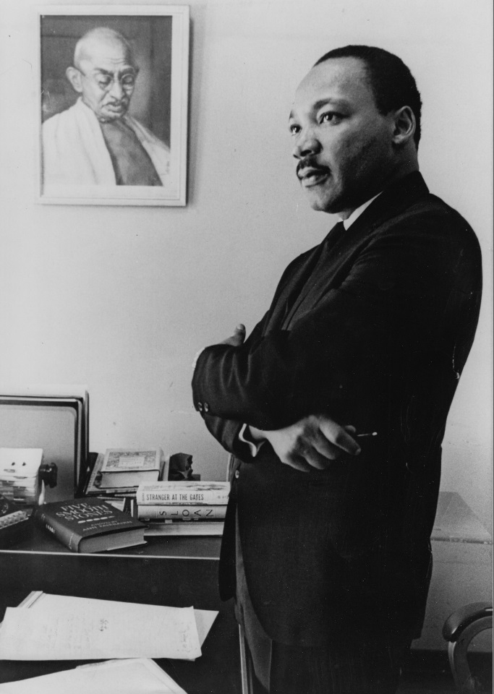
This photograph, taken in King’s SCLC office in Atlanta, symbolizest Gandhi’s influence on him. The stark difference in their clothing also hints at their differing views on modernity. This photograph served as the model for King’s statue at the King Memorial in Washington, D.C. (Bob Fitch Photography Archive, Stanford University)
King does not inform us whether Hind Swaraj was among the “half-dozen books on Gandhi’s life and works” that he bought that day, but it appears that while he enthusiastically embraced the Gandhian technique of non-violent resistance, he did not display any real enthusiasm for the Gandhian notion that we must abandon our modern scientific-technological civilization and return to a village-based agrarian society.
In 1959, King and Coretta King embarked on a four-week tour of India. During this tour, he had the opportunity to visit, and to observe at close quarters, some ashrams (communes) and villages that were inspired by the Gandhian vision of an agrarian society made up of small autonomous villages. King expressed respect for such social experiments, but does not seem to have been convinced that village-based agrarian society was any better than urban industrialized society. James Bristol, who accompanied the Kings on their tour recorded his impressions of King’s visit to an ashram run along Gandhian lines by Jayaprakash Narayan,
Jayaprakash Narayan rode with us… and a most stimulating conversation ensued... Martin found J.P.’s decentralist ideas challenging, but could not go as far as J.P. is prepared to go. The next day, after a long jeep ride to reach J.P.’s Ashram, he was to point out that even Jayaprakash Narayan is dependent upon a factory-produced vehicle to keep his Ashram in touch with the surrounding community. (Bristol)
King did not claim to have a ready answer for India’s problems, but he supported industrialization and modernization, and called upon the United States to assist India with capital and technical know-how.
King’s indifference towards the Gandhian agrarian vision and his preference for modern industrial society was deeply rooted in his core ethical values and beliefs. Both King and Gandhi were deeply religious, but the religious lens through which King viewed modernity was very different from that used by Gandhi. In a 1949 essay comparing liberalism and fundamentalism, in which he displayed a clear preference for liberalism, King wrote that “when man finds himself amid a changing society” caused by scientific and technological progress, he has two choices,
Either he attempts to adjust his thinking to the changing conditions or he attempts to hold to old dogmatic ideas amid the new. Fundamentalism chose the latter while liberalism chose the former…
…liberalism is a progressive movement which came into being in an attempt to adjust religion to all new truth. Just as the Scholastics attempted to wed theology to the dominant thought pattern of their day, viz., Aristotelian philosophy, the modern liberal attempts to wed theology to the dominant thought pattern of his day, viz., science. The liberal doesn't mind changing old world views to fit the scientific world view. (King, The Sources)
According to King, Black Americans, long forced to live within a fundamentally unjust agrarian social order, had developed an inferiority complex. Modernity, claimed King, had finally upset that order, enabling Blacks to purge their inferiority complex and claim their self-respect. In a speech in Detroit in June 1963, considered to be a precursor of his famous Dream speech, King argued,
Now Birmingham and the freedom struggle… reveal to us that the Negro has a new sense of dignity and a new sense of self-respect… I think we all will agree that probably the most damaging effect of segregation has been what it has done to the soul of the segregated as well as the segregator. It has given the segregator a false sense of superiority and it has left the segregated with a false sense of inferiority...
But then something happened to the Negro. Circumstances made it possible and necessary for him to travel more: the coming of the automobile, the upheavals of two world wars, the Great Depression. And so his rural, plantation background gradually gave way to urban, industrial life. And even his economic life was rising through the growth of industry, the influence of organized labor, expanded educational opportunities. And even his cultural life was rising through the steady decline of crippling illiteracy. And all of these forces conjoined to cause the Negro to take a new look at himself. Negro masses, Negro masses all over began to re-evaluate themselves, and the Negro came to feel that he was somebody.
Clearly, King viewed scientific, technological and economic progress as fundamentally emancipatory for Blacks. For King, it was modernity that made the Dream possible. King went on to conclude his Detroit speech with a ringing declaration, which, in slightly modified form, he would repeat two months later at the March on Washington,
I have a dream this afternoon that the brotherhood of man will become a reality in this day.
And with this faith I will go out and carve a tunnel of hope through the mountain of despair… (King, Speech)
In an address in 1957, King lauded American scientific, technological and economic progress,
The scientific and technological advances made by this Nation still astound and stagger the imagination… Not only have we made great progress in the area of technology and science, but we have made unprecedented strides in the area of economic growth... All of this is a dazzling picture of U.S.A. 1957. (King, The Role)
King then pointed out the dark side of the U.S.A., 1957,
But there is another side of our national life which is not so bright. In the midst of all of our scientific and technological advances, we still suffer the plague of racial conflict. We have not learned the simple art of loving our neighbors, and respecting the dignity and worth of all human personality. Through our scientific genius, we have made of the world, a neighborhood, but through our moral and spiritual geniuses, we have failed to make of our own Nation a brotherhood. This is the chief moral dilemma of our Nation. (King, The Role)
Thus, King recognized that in spite of rapid scientific, technological and economic progress, American society had not been able to banish injustice. But the root of the problem, insisted King, was not that modernity, with its rapid technological and economic advances, was taking us further and further away from the idyllic village-based agrarian society of our forefathers, but rather, that our moral and spiritual development was not happening rapidly enough. King appealed fervently for a more energetic push for moral development,
A second challenge facing us… is to keep our moral and spiritual development in line with our scientific and technological growth. Certainly, one of the tragedies of the present era is modern man’s blatant failure to bridge the gulf between scientific means and moral ends… Moral stagnancy is not only intolerable, but suicidal. (King, Remaining Awake)
The urgent need for rapid moral development to keep up with scientific, technological and economic progress was something that King considered critically important, as his characterization of this as “the chief moral dilemma of our Nation” indicates. According to Stanford University professor Clayborne Carson, this was “one of King’s most consistent themes of his lifelong ministry” (Carson).
King is a venerated figure in America today. Most Americans claim to share King’s dream of freedom and justice for all. However, many Americans who claim to be interested in promoting social justice, implicitly, if not explicitly, reject King’s view that scientific, technological and economic progress can be fundamentally emancipatory, and tend to view these with extreme suspicion. One representative of this group is Wendell Berry, one of the leading figures of the local and organic food movement, of whom the popular food writer Michael Pollan states, “in a way, all my writing about food has been about connecting dots in the way Berry asks of us” (Fassler). Even many of those who have never read Wendell Berry, or have even heard of him, have unknowingly adopted some of his ideas. Referring to the White House organic kitchen garden, and some of President Barack Obama’s pronouncements, Pollan notes, “I have no idea if Barack Obama has ever read Wendell Berry, but Berry’s thinking had found its way to his lips” (Pollan x).
In moving poetry and eloquent prose, Berry vividly celebrates the traditional way of farming in rural North-Central Kentucky, and laments the mechanization, industrialization and urbanization of America. The agrarian society that Berry so lovingly glorifies, however, is none other than the agrarian society of the Jim Crow South.
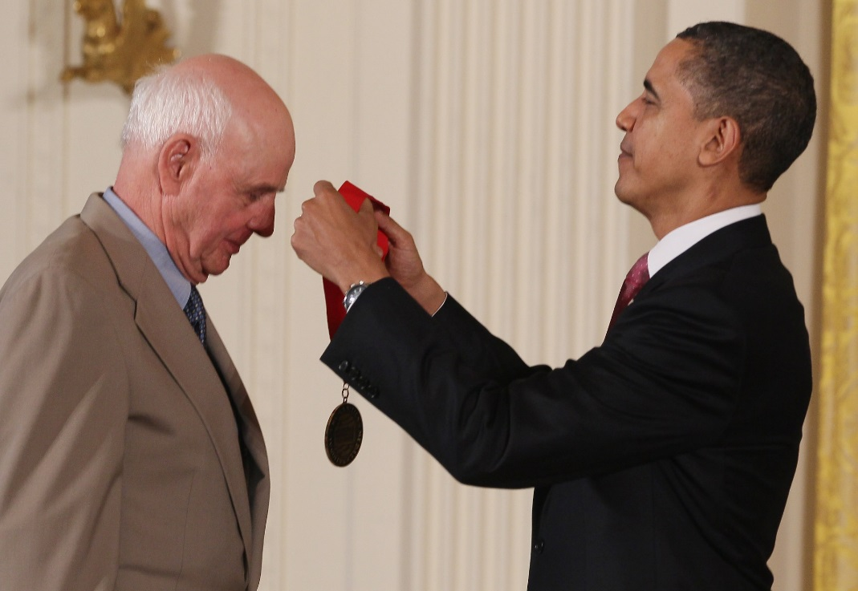
Wendell Berry receiving the National Humanities Medal in 2010 (Wikipedia)
In The Hidden Wound, written in 1969, Berry explores his family’s legacy of slave-owning, and his own experience of living in a segregated society. Berry displays a very high regard for Black people and praises their culture, but this praise reveals a value system that is diametrically opposed to King’s conception of freedom and justice,
[The white laborer] worked with the idea that his work would lead to ownership, or that at least, as a white man, the nigger work he was doing was unworthy of him; in neither case, because of his sense of racial superiority, did he find it necessary to come to emotional or philosophical terms with the work he was doing. Only the black man, the nigger to whom nigger work was appointed, for whom there was no escape, was able to face it as a present and continuing necessity, and to invent the means of enduring and living with it - and, if I understand the communal and emotional impetus of the work song, of building a culture, not beside or in spite of that necessity, but upon it to triumph over it. It seems to me that the black people developed the emotional resilience and equilibrium and the culture necessary to endure and even enjoy hard manual labor wholly aside from the dynamics of ambition. (Berry 81)
In Berry’s value system, the very inability of Blacks to escape “nigger work” is viewed as leading to a positive outcome: a culture and an outlook that allowed them to fully appreciate the beauty and joy of lifelong hard manual labor in the fields, uncontaminated by any sense of ambition. Berry also writes movingly of his memory of Nick, a Black laborer on his grandfather’s farm. Referring to Nick, Berry writes,
In these times one contemplates it with the same sense of hope with which one contemplates the sunrise or the coming of spring: the image of a man who has labored all his life and will labor to the end, who has no wealth, who owns little, who has no hope of changing, who will never “get somewhere” or “be somebody,” and who is yet rich in pleasure, who takes pleasure in the use of his mind! Isn’t this the very antithesis of the thing that is breaking us in pieces? (Berry 75)
In Berry’s portrayal, Nick stands as a moral exemplar because he was someone who never aspired for anything different, never questioned the socio-economic order of the Jim Crow South, but found joy and beauty and grace, living and working entirely within the constraints and limits of the place and the society that he was born into. In Berry’s view, Nick stands as a moral exemplar precisely because he did not have a dream.
Ultimately, King praises modernity and excoriates traditional Southern society for the very same reason that Berry criticizes modernity and glorifies the traditional agrarian socio-economic order of the South: for providing Blacks the means and the opportunity to dream of a different future.
In America today, the public debate over the direction and the ethics of modernity is an important one. However, while this debate prominently features some voices, such as Berry’s, that tend to be inimical to King’s values, King’s own views are generally missing. It is hoped that the inclusion of King’s perspective on modernity will add to the richness and diversity of this important public debate, and enhance its relevance to America society.

References

Berry, Wendell. The Hidden Wound. Counterpoint, Berkeley, 2010. Kindle Edition.
Bristol, James. Notes from the Tour Diary of James Bristol. First produced 1959. Electronic format.
Carson, Clayborne. Introduction to Civilization’s Greatest Need, a message delivered by King, Dr. Martin Luther, Jr. in 1949. Available at http://mlk-kpp01.stanford.edu/primarydocuments/Vol6/1949Civilization%27sGreatNeed.pdf. Electronic format.
Fassler, Joe. “The Wendell Berry Sentence That Inspired Michael Pollan's Food Obsession” in The Atlantic, April 23, 2013. Available at http://www.theatlantic.com/entertainment/archive/2013/04/the-wendell-berry-sentence-that-inspired-michael-pollans-food-obsession/275209/. Electronic format.
Gandhi, Mohandas K. Indian Home Rule or Hind Swaraj. Navajivan Publishing House, Ahmedabad, 1938. First published in 1909. Available at http://tinyurl.com/GandhiHindSwaraj. Electronic format.
King, Dr. Martin Luther, Jr. The Autobiography of Martin Luther King Jr., Carson, Clayborne, ed., Grand Central Publishing, New York, 1998. Print.
King, Dr. Martin Luther, Jr. The Sources of Fundamentalism and Liberalism Considered Historically and Psychologically. Essay written for a class “Theology for Today,” 13 September - 23 November 1949. Available at http://mlk-kpp01.stanford.edu/kingweb/publications/papers/vol1/491123-The_Sources_of_Fundamentalism_and_Liberalism.htm. Electronic format.
King, Dr. Martin Luther, Jr. Speech at the Great March on Detroit. Address delivered at Cobo Hall in Detroit on June 23, 1963. Available at http://kingencyclopedia.stanford.edu/encyclopedia/documentsentry/doc_speech_at_the_great_march_on_detroit.1.html. Electronic format.
King, Dr. Martin Luther, Jr. Remaining Awake Through a Great Revolution. Address delivered at the Morehouse College on June 2, 1959. Available at http://mlk-kpp01.stanford.edu/index.php/encyclopedia/documentsentry/remaining_awake_2_june_1959. Electronic format.
King, Dr. Martin Luther, Jr. The Role of the Church in Facing the Nation's Chief Moral Dilemma. Address delivered at Nashville on 25 April 1957. Available at http://mlk-kpp01.stanford.edu/kingweb/publications/papers/vol4/570425.002-The_Role_of_the_Church_in_Facing_the_Nations_Chief_Moral_Dilemma.htm. Electronic format.
Pollan, Michael. “Introduction,” in Berry, Wendell, Bringing it to the Table, Counterpoint, Berkeley, 2009. Print.

The strongest objections to Gandhi’s anti-modernizing views were expressed by the Dr. Babasaheb Ambedkar, a leader venerated by India’s untouchable castes (the Dalits).
Southern Christian Leadership Conference

