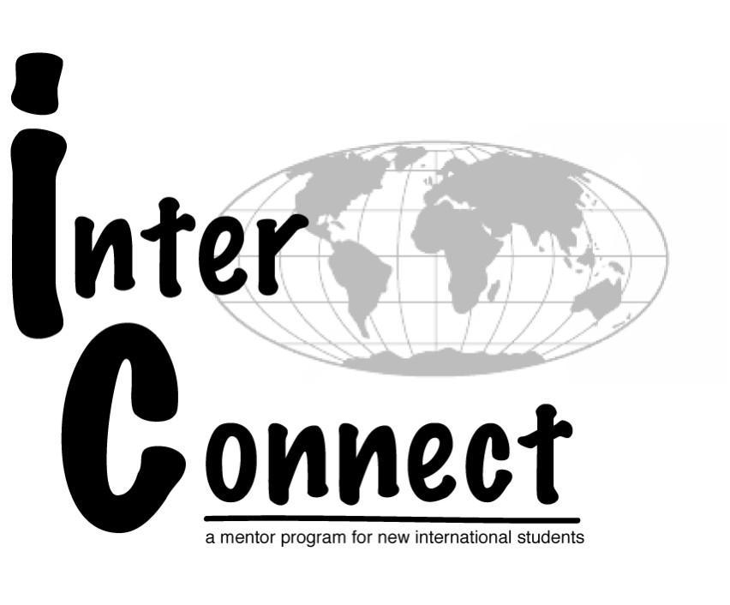
InterConnect Mentor Application
Fall 2015

This application must be completed in full for consideration. Please type and submit this application electronically to dlawson@reed.edu by 5:00pm on Friday, February 20th at 5:00pm.. Please include an electronic copy of your resume with this application detailing your campus involvement, awards and recognition, previous international experiences, and work experience.

Application Timeline:
- Thursday, February 5th, 4-5pm, GCC 103 - Position Info Session
- Friday, February 20th at 5pm - Applications due
- February 24-25th - Sign up for interviews
- February 26th - March 3rd Interviews
- Friday, March 13th - Selection notification

General Information:

Name: Reed ID#:

Email: Phone:

Reed MS#:

Current Year in School: Major:

Language(s) spoken (not a required skill):

Countries where you’ve lived/studied abroad (not a required experience):

Interests/Hobbies:

Have you participated in the InterConnect program before?
If Yes, in what capacity?

Can you attend all of the required training and early arrival dates listed below?
- April 10-11th - Spring Training and retreat
- August 19th - Early move-in date
- August 20st - Orientation preparation and training
- August 21-24th - Staff International Student Orientation

There is also an opportunity to work over the summer and take on additional leadership responsibilities as the Orientation Coordinator and Lead InterConnect Mentor. Would you like to be considered for this position? Please refer to the Lead InterConnect position description.

References
Please list two campus references. Reference must be a faculty member, staff member, or your current HA.

Reference #1:

Name: Position/Title:

Relationship: Phone: Email:

Reference #2:

Name: Position/Title:

Relationship: Phone: Email:

Essay Questions:
Please answer each question completely and succinctly.

1. Why are you interested in applying to be a mentor and orientation leader in InterConnect? What do you hope to gain from the program?

2. What do you see as the purpose and role of a mentor in this program?

3. What qualities or abilities do you possess that would be useful to you as part of the InterConnect program? Please explain.

4. What experiences have you had with cultures different from your own? What did you learn from these experiences?

5. What is one thing that you would want a new student to know about Reed that you didn’t know when you arrived?

6. List any related or additional cross-cultural education, training, or experience.

