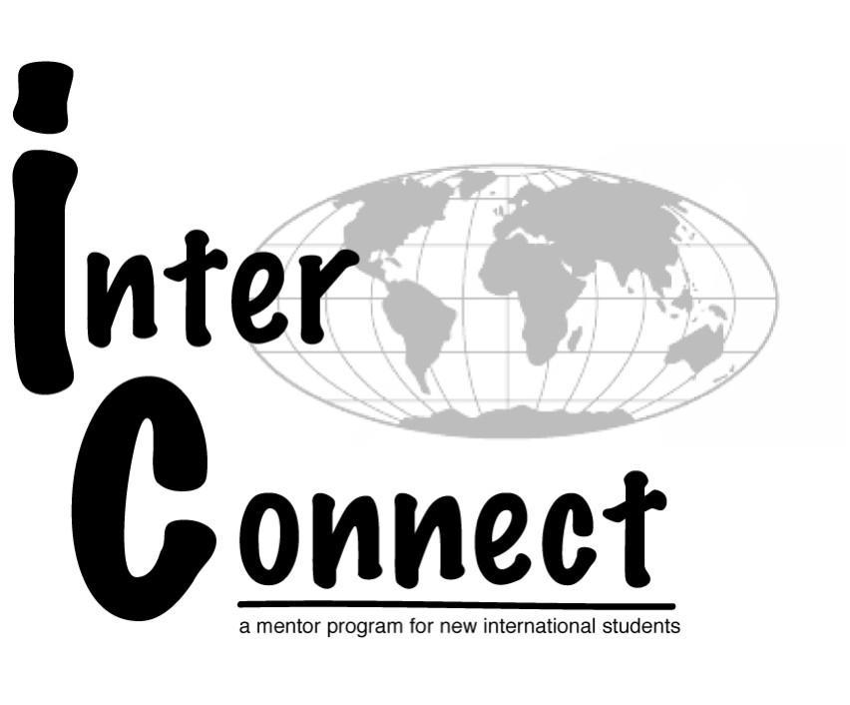
InterConnect Mentor Application
Fall 2016

This application must be completed in full for consideration. Please type and submit this application electronically to dlawson@reed.edu by 5:00pm on Friday, February 12th at 5:00pm.. Please include an electronic copy of your resume with this application detailing your campus involvement, awards and recognition, previous international experiences, and work experience.

Application Timeline:
- Tuesday, February 2nd, 4-5pm, ISS Office - Position Info Session
- Friday, February 12th at 5pm - Applications due
- February 16th -17th - Sign up for interviews
- February 24th – March 1st - Interviews
- Friday, March 11th - Selection notification

General Information:

Name: Reed ID#:
Email: Phone:
Reed MS#:
Current Year in School: Major:

Language(s) spoken (not a required skill):

Countries where you’ve lived/studied abroad (not a required experience):

Interests/Hobbies:

Have you participated in the InterConnect program before? Yes No
If Yes, in what capacity?

Can you attend all of the required training and early arrival dates listed below?
- April 8th - 9th - Spring Training and retreat
- August 17th - Early move-in date
- August 18th - Orientation preparation and training
- August 19th - 22nd - Staff International Student Orientation
Yes No

There is also an opportunity to work over the summer and take on additional leadership responsibilities as the Orientation Coordinator and Lead InterConnect Mentor. Would you like to be considered for this position? Please refer to the Lead InterConnect position description.
Yes, I would like to be considered for Orientation Coordinator and Lead InterConnect Mentor.
No, I would not like to be considered for Orientation Coordinator and Lead InterConnect Mentor.

References
Please list two campus references. Reference must be a faculty member, staff member, or your current HA.

Reference #1:

Name: Position/Title:
Relationship: Phone: Email:

Reference #2:

Name: Position/Title:
Relationship: Phone: Email:

Essay Questions:
Please answer each question completely and succinctly.

1. Why are you interested in applying to be a mentor and orientation leader in InterConnect? What do you hope to gain from the program?

2. What do you see as the purpose and role of a mentor in this program?

3. What qualities or abilities do you possess that would be useful to you as part of the InterConnect program? Please explain.

4. What experiences have you had with cultures different from your own? What did you learn from these experiences?

5. What is one thing that you would want a new student to know about Reed that you didn’t know when you arrived?

6. List any related or additional cross-cultural education, training, or experience.

