Zoo Field Trip for Ethograms
For a description of the recording methods read chapter 6 in Martin and Bateson.
Before lab check out the website (http://www.oregonzoo.org/ ), read this handout and think about what animals you want to observe and what questions one can ask in a zoo?
The day of lab bring your lab notebook and these instructions. Meet in the lab at 1:00, Pick up a stopwatch or timer. Wear appropriate clothing for the weather.

ETHOGRAM
An ethogram is a primary tool in ethology. Ethology is a zoological, evolutionary approach to animal behavior that includes examination, generally under natural conditions, of the proximate causes and development of behavior as well as the ultimate evolution and adaptive value. The ethogram is a catalogue or dictionary of the discrete behaviors typically employed by a species. The included behaviors are sufficiently stereotyped that an observer may record the number of acts, or the amount of time engaged in the behaviors. The ethogram may include drawings (or photographs) in addition to a written description of each discrete behavior. In an ethogram, behaviors are described without explicit reference to their purpose. For example, although a specific movement may represent a putative threat display it should be given an objective name such as "head forward" or "bracing display", and not "head forward threat" or "bracing threat". The definition of the display as a component of antagonistic interactions arises from the context and surrounding behaviors in which the display is observed. Ethograms often represent an early stage of investigating the behaviors of a species and the contexts in which they occur, but may also be the basis of formal scientific research. In the early years of animal behavior, the primary goal of many studies was the description of behavior. Although complete ethograms are rarely published anymore in behavior literature, they are often used by zoos to describe normal behavior and monitor captive behavior in order to identify pathology due to illness or poor animal care. Ethograms also serve as a valuable tool for many lab and field experiments on both model organisms and ecological studies As a too,l the ethogram usually describes only a small portion of the complete behavioral repertoire.

Follow these links to see different types of ethograms:
--An ethogram for behavioral genetic studies in a model organism (Drosophila)
http://labworks.hms.harvard.edu/fruit_fly/thriller/index.html
--An ethogram to monitor captive “behavioral syndrome” (horse)
http://www.lincoln.ac.uk/dbs/research/headshaking/ethogram.htm
--An ethogram to monitor captive normal behavior (tamarins)
http://gargoyle.arcadia.edu/biology/tamarin/Methods/Ethogram/ethogram.htm
--An ethogram for social behavior (Anolis) (follow the links from here for video examples and measurement methods)
https://notes.utk.edu/bio/greenberg.nsf/63bbb8a8bd4c0eef852563ed0072e463/086a04290e49e24885256b0a00497920?OpenDocument
--An ethogram focused on facial and verbal communication (chimpanzees)
http://webdrive.service.emory.edu/groups/research/chimpanzee-cognition/CCL/ethogram.htm
--An ethogram for field work (cockatoo)
www.santafe.edu/~jpepper/thesis/03-Ethogram.pdf

In lab this week you will build an ethogram and develop a hypothesis that can be tested in the zoo. You will use different Sampling and Recording techniques in order to collect data and determine the best method given your goals.

AT THE ZOO:
Walk around and appreciate the animal diversity. Then working with a partner, choose an animal, or group of animals, or even an enclosure with multiple species, that you will observe for the next 3 hours. Keep in mind that large charismatic animals are often very boring to watch for 3 hours, birds and small mammals are often more active. Your goal today is to learn something about the behavior of the animal in the zoo. You will be asked to formulate a question and then collect data to answer that question. Several types of questions can be asked and answered with behavioral observation within a zoo setting. Remember that a zoo has several goals in addition to public entertainment, the zoo also aims to educate the public, engage in conservation programs for endangered animals, and also participate in basic research.
Your own question and observations today should address one of these areas.
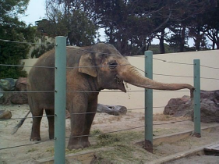
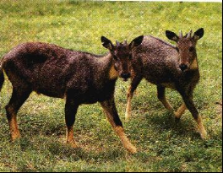
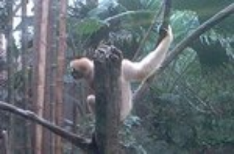

A
B
C
C

You may be concerned with the welfare of a particular animal such as Sayer et al., (2007)(A) who studied the behavior of a particular one-armed gibbon in the Lincoln park zoo. Or you may be interested in how a particular aspect of the enclosure affects animal behavior. David Shepherdson and colleagues have recently redesigned the elephant house here at the Oregon Zoo (B) because of a study regarding flooring type (Meller et al., 2007). Simple behavioral descriptions are often possible in a zoo that would be much more difficult to obtain in the wild but which will greatly facilitate future identification of behavior in the wild, for example, differentiation of two species (Marlof et al., 2007) or the details of mating behavior (Xie, 2006)(C). The zoo setting also offers the possibility to repeatedly obtain physiological measures or hormone samples from the same individual, making captive animals a great resource for understanding animal biology. Consider how your own questions might be augmented by such repeated measures, though this is beyond the scope of our exercise today.
Today you will create an ethogram and pose a question. You will then apply different recording and sampling techniques in order to devise a protocol that will allow you to address your question. The data you collect today can be viewed as "preliminary data" for a larger study. When you applying for a grant to conduct a large study it is important to have solid preliminary data and a detailed protocol in order to demonstrate to the granting agency that your study is not only worth doing, but also that it is doable.
Your data should either be recorded on the data sheets provided and permanently attached to your lab notebook or recorded directly into your lab notebook.

BACKGROUND INFORMATION - Record
- Common name and scientific name and geographical distribution of animal:
- What characteristics can be used to distinguish sex, age and individuals?
- Describe the zoo enclosure habitat and population objectively (sketch the cage?).
- Describe the zoo habitat subjectively, compare it to the animal's wild habitat.

FIRST OBSERVATION – Ad libitum – 15 minutes
Fifteen minutes (or more) ad libitum (record everything you see),
SECOND OBSERVATION – create an ethogram ~ 15 minutes
Using your first observation notes and any ongoing observation spend some time to make an ethogram of the behaviors you expect to see during your later observations. The ethogram should be as complete as possible describing as many discrete behaviors as you observe. Include drawings if appropriate.

BEFORE GOING ANY FURTHER - formulate a question - 15 minutes
With your partner, formulate a question or two about the animals and enclosure you are observing. Is there a dominance hierarchy? Are the females more aggressive than the males? Do the juveniles have a different time budget than the adults? Which food source is preferred? Decide which behaviors will be important to record in order to address your question. You will try scan sampling, focal sampling, behavior recording and 1/0 instantaneous recording in order to determine the most accurate and efficient mechanism to collect the necessary data to address your question.

THIRD OBSERVATION – Scan sampling– 15 minutes
Use your ethogram to do a fifteen minute scan (or instantaneous) sample with timed recording. At the end of each 2 minute interval record what each animal in the cage or enclosure is doing. (Can individuals be unambiguously identified?). This method gives a snapshot picture of behavior. Unless there are multiple animals in your enclosure this will be no different than instantaneous recording, the value of scan sampling is that it allows collection of data from large groups of individuals. It does not provide the most accurate time budget.
FOURTH OBSERVATION – focal sampling– 20 minutes
Use your ethogram to do a five minute focal sampling with continuous recording for each individual in the enclosure (up to 4 animals). The value of focal sampling is that it can be used to construct accurate time budgets based on individuals.
FIFTH OBSERVATION – behavior sampling – 15 minutes
From your ethogram, select one or two behaviors that occur most frequently. For these behaviors record each instance of the behavior that occurs in a 15 minute period (record the time if possible, and the individual if possible to identify). Like scan sampling, behavior sampling allows you to collect data from multiple individuals simultaneously, but because you use continuous recording you will obtain more accurate measures of specific behaviors although it is not possible to count as many behaviors.
SIXTH OBSERVATION – 1/0 method - 15 minutes
Use your ethogram to do 3 five minute 1/0 recording. Record only whether the behavior did or did not occur during that five minutes. The value of 1/0 recording is that it allows for a greater number of behaviors to be scored and captures brief intermittent behaviors.
AFTER THE ZOO:
1) One page written "grant application"
What question do you propose to address?
Why is this question important?
Why is the zoo the proper place to address this question? (if not state why)
What is the observation protocol you propose? (if your question would require physiological measures or tissue samples, state this but do not go into detail on those methods).
Why is this observation technique better than another possible technique?
Can you provide preliminary data to demonstrate the feasibility of this study? (a single graph, or table is sufficient)

(The proposal will be evaluated for clarity of this, and demonstration that you have mastered the concepts of behavioral. The proposal will NOT be evaluated on the relative scientific merit of the project, or the quality of the preliminary data).
Post this on the courses server BEFORE lab next week.
Attach a copy to your lab notebook.

2) Prepare a single (or two) power point slides of your data to present in lab class next week.
Post this on the courses server BEFORE lab next week.

References available on the courses server or see Zoo Biology journal for many more examples.

Marlof, B., McElligott, A.G., Miler, A.E. (2007) Female social dominance in two Eulemur species with different scocial organizations Zoo Biology 26:201-214.

Martin and Bateson "Measuring Behavior: an introductory guide. 2nd edition" Cmabridge University Press 2001.

Meller, C.L., Croney, C.C., Shepherdson, D. (2007)
Effects of rubberized flooring on Asian elephant behavior in captivity. Zoo Biology Zoo Biology 26:51-61.

Sayer, E.C., Whitham, J.C., Margulis, S.W. (2007) Who needs a forelimb anyway? Locomotor, postural and manipulative behavior in a one-armed gibbon Zoo Biology 26:215-222.

Xie, Y. (2006) Primary observations on rutting behavior of the captive red goral Zoo Biology 25:117-123.

FIRST OBSERVATION – Ad libitum – 15 minutes

SECOND OBSERVATION – create an ethogram ~ 15 minutes
Behavior | Description | sketch
1
2
3
4
5
6
7
8
9
10
11
12
13
14
15
16
17
18
19
20

THIRD OBSERVATION – Scan – 15 minutes

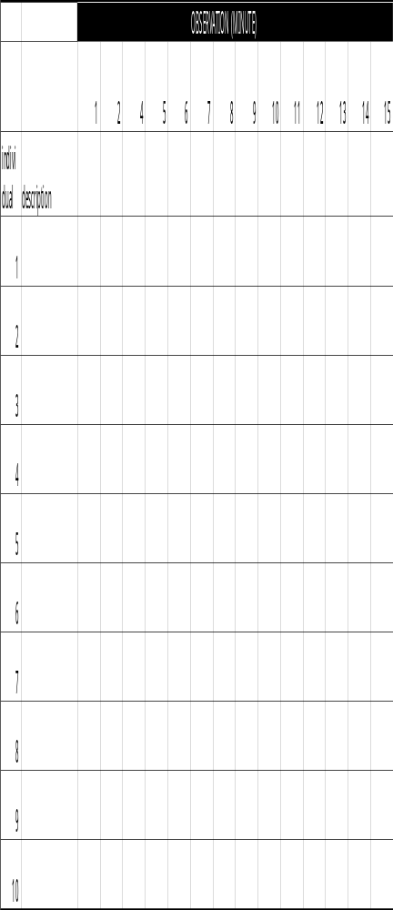
Write a very brief description of each individual in the cage.
Use a code for each behavior.

At the end of each minute record the
behavior of each individual.

FOURTH OBSERVATION – focal – 5 minutes each (20minutes total)
Use a tick mark to record each occurrence of each behavior for the focal animal
Behavior | focus on 1 | focus on 2 | focus on 3 | focus on 4
1
2
3
4
5
6
7
8
9
10
11
12
13
14
15
16
17
18
19
20

FIFTH OBSERVATION – behavior record – 15 minutes
Explain why you selected these behaviors (are they related, of particular interest, too difficult to accurately record with the other methods etc.)

 |  |  | SELECTED BEHAVIORS
 |  | 1 | 2 | 3 | 4 | 5
individual | description
1
2
3
4
5
6
7
8
9
10

SIXTH OBSERVATION – 1/0 method - 5 minutes each (15 minutes total)
Use a 1 or a 0 to record whether or not each behavior occurs during each observation
Behavior | period 1 | period 2 | period 3
1
2
3
4
5
6
7
8
9
10
11
12
13
14
15
16
17
18
19
20

